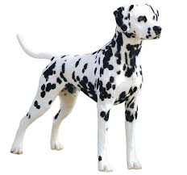
Weekly Challenges
Dalmatian home learning
Week Beginning 15th June

Hello Everyone,

Here are this week’s challenges: pirate themed of again. I’d welcome some feedback on the challenges: are they relevant and achievable at home?
Again, please do email me pictures! Get in touch with me if you need to at any time.
kblack@granta.cambs.sch.uk

Katie and the Dalmatian team.

- Make a Pirate ship
You will need:
An old egg box
Straw for the mast
Paper for the sail
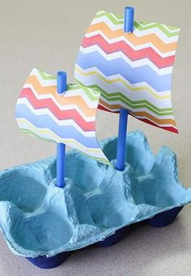

Decorate your sails before you put them on!

Language and Communication
This activity will need some heavy adult support and modelling – work hand over hand with your child, using simple key words. Allow plenty of play time with the finished product!
- See it, Make it, Write It –
You will need:
Some small Items for counting
The attached counting sheet

Here is a video for you to watch on how to complete this task.

https://vimeo.com/429953270

- Underpants science experiment
You will need:
A white crayon
Water based paints
Underpants template
https://vimeo.com/427289469

- Make marks in white crayon on your template. Help them to press quite hard!
- Magic painting – use your water based paint to reveal the marks.
- Encourage your children to find and follow the marks they made on their pants!

- Pants matching

You will need:
The attached pants matching sheet

Prepare the activity for your child by pre-cutting the symbols. Use simple language such as ‘find the same’ and, if you feel it is appropriate for your child, you could introduce some simple descriptive words e.g. ‘spotty pants’!

- Phonics ‘p’
Here is a video lesson on ‘p’.

https://vimeo.com/429956076

Remember to email your pictures to kblack@granta.cambs.sch.uk I absolutely love seeing them!

