Hedgehog
Stories
- The Tale of Mrs Tiggy-Winkle – Beatrix Potter
- The Hodgeheg – Dick King-Smith
- The very helpful hedgehog – Rosie Wellesley
- Harold the Hedgehog audio book https://www.youtube.com/watch?v=tAytsLbkTzI
- Don’t hog the hedge – ebook available on twinkl
Activities
- Research hedgehog awareness week
https://www.britishhedgehogs.org.uk/hedgehog-awareness-week-2020-3rd-may-9th-may/
https://www.hedgehogstreet.org/hog-awareness-week/
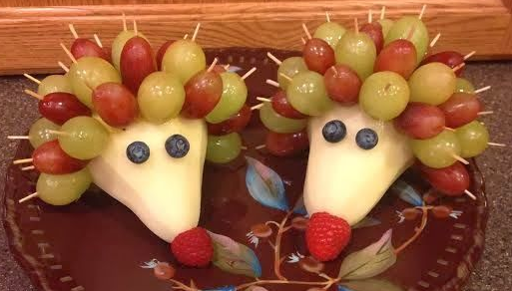
- Make a fruit hedgehog for snack
- Make a leaf hedgehog
- Make a hedgehog house or feeding
station
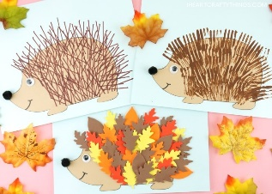
- Make a clay hedgehog how can you make
the texture for the prickle?
– scissor cut the clay, push sticks or straws in
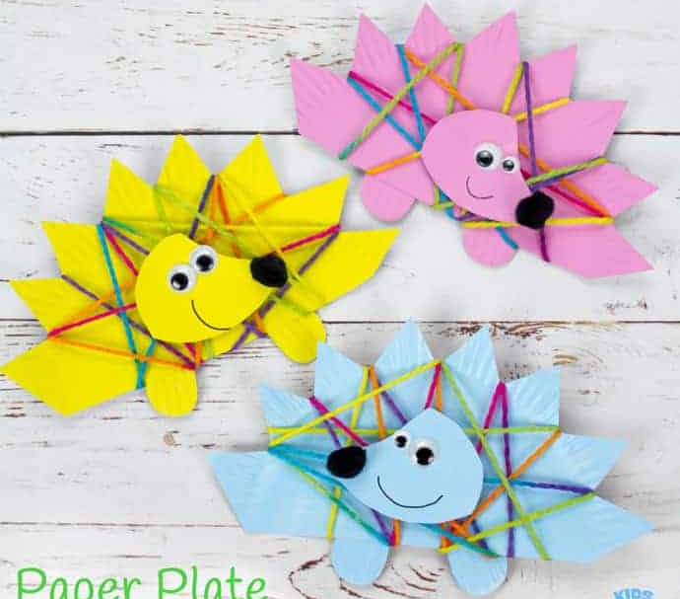
- Paint hedgehogs – what different items
can you use to create prickles? Fork, sticks,
hand prints?
- Hedgehog comprehension worksheets
- Hedgehog paper plate weaving
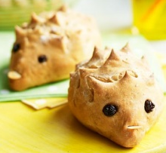
- Make hedgehog bread rolls
bbc good food website for recipe

