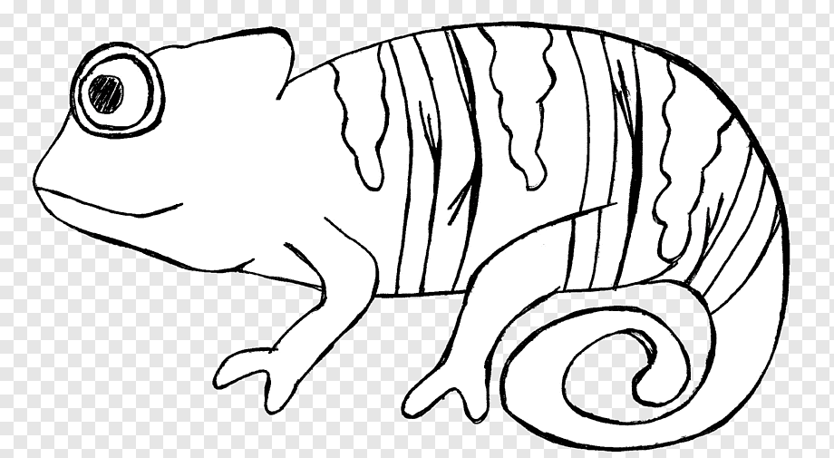

1st colour in your chameleon template
2nd cut out your template very carefully, then cut along the red line
3rd attach your chameleon to a wooden clothes peg like this

4th get a piece of pipe cleaner and pop it into the middle of the peg like this

Finally enjoy playing with your Chameleon

