It is time for week 5 of the Silly Squad summer reading challenge. This week our story is While we can’t hug by Eoin McLaughlin and Polly Dunbar.

It is a lovely story, it makes you feel fluffy inside. Best friends, hedgehog and tortoise live in strange times. They cannot touch or hug each other but they find ways to see each other and make each other feel fluffy inside.

I hope you enjoy the story, it is one of my favourites.

First, time to put on your dancing feet. Take your shoes off and get ready:

Activity 1: Wake up, give your body a shake

https://www.youtube.com/watch?v=1gUbdNbu6ak

Activity 2: Funny face, page 2.

Use the template on page 2 to draw and colour in a funny face. It can be as crazy as you like. All you need is:

- Paper
- Crayons or felt tips

Activity 3: Make your own music

Find a friend, someone in your class or someone in your family. Take turns choosing your favourite songs and make your own music singing your songs together.

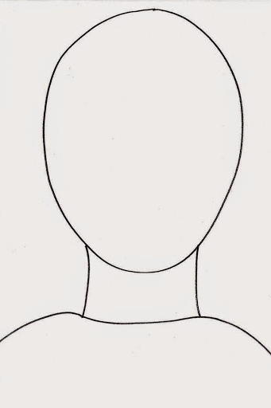

Activity 4: Build you own Odd dog page 4 (if you have time).

Do this one with someone in your family. If you can, take a photograph of your finished odd dog and send it to your teacher.

Activity 5: The big tidy up

- Put everything away
- Put all your rubbish in the bin, do not forget to recycle what you can
- Wash and dry your hands

Activity 4: How to grow a rainbow
Now for the science bit, you will need:
You will need:

Kitchen roll
Felt tip pens
Two small bowls of water
Paper clip or clothes peg
Thread

Method:

1. Cut your kitchen towel into the shape of a rainbow
2. Colour a rainbow with felt tips about 2cm up on both sides
3. Attach a paper clip or cloths peg to the top and tie a piece of
thread to it. This will you give something to hold onto
4. Fill each small container with water
5. Hold your rainbow with the ends slightly submerged in the water
and watch your rainbow grow. Carefully let go and walk away.

Keep coming back to check on your rainbow over the next two hours. What happens?
Activity 5: Write a letter and make someone feel fluffy inside

Write a letter (or draw a picture) and send it to someone you haven’t seen for a very long time? Ask a grown up to help you post it.

All you need is:

- Paper
- Pen, pencil and crayons
- Envelop and a stamp

Activity 6: The big clear-up

- Put everything away
- Put all your rubbish in the bin, do not forget to recycle what you can
- Wash and dry your hands. (Don’t forget to wash your nails too!)

Activity 7: Me time, dragon breathing practice

After all your hard work take five minutes ME time. If the sun is shining and you have a garden go outside for some fresh air. Remember to put you sun hat and sun cream on. Too hot? Find some place cool and quiet.

- Sit cross-legged on the floor, remember to keep your spine long and sit tall
- Close your eyes, breathe in through your nose
- Breathe out through your mouth, whispering a roar

Now for the funny bit:

- Stick your tongue out and open your eyes wide.

Start the exercize again and repeat twice more

Activity 8: Sharing a digital story:

While we can’t hug by Eoin McLaughlin and Polly Dunbar

1. Click on the Youtube link below; watch and listen to the
story:

https://www.youtube.com/watch?v=t8ZPAo5ioIU

2. Fill in your story record sheet.

3. Do you recommend this story: Yes / No

4. If you share a story or read a book at home, add it to
your reading record. If you enjoyed this story, let
your teacher know.

5. Keep reading and sharing stories

I hope you enjoyed this week’s story.

Well done everybody, give yourself a squeeze hug:

