soft g

p | a | g | e | z | s | t | a | g | e | w
b | m | f | x | s | g | i | n | r | e | d
i | u | m | a | g | i | c | y | t | r | n
m | n | u | y | p | i | g | e | o | n | g
f | r | a | n | g | e | l | o | p | t | k
g | e | m | j | l | g | i | a | n | t | z
s | a | c | a | g | e | x | z | v | a | x
u | y | t | r | e | g | e | r | b | i | l
g | e | r | m | t | b | n | h | j | u | i
m | k | l | d | e | f | g | e | n | i | e
giant genie angel germ 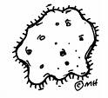 cage stage
gin pigeon page gem gerbil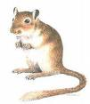 magic

