It is time for week 7 of the Silly Squad summer reading challenge. This week our story is The Koala who could by
Rachel Bright and Jim Field.

Kevin is a Koala who loves life as it is but one day everything changes. See what happens when his tree begins to fall down and, how his friends help him.

This is our last week of our school reading challenge, I hope you enjoy the story.

Now, it is time wake your bodies up but first, choices! Over the last seven weeks you have:

- practiced your Yoga
- shaken your sillies out
- got physical with Joe Wicks

so today you can choose which physical activity you would like to do. Click on your chosen link below and get PHYSICAL!

Activity 1:

Shake your sillies out:
https://www.youtube.com/watch?v=NwT5oX_mqS0

Time to get active with Joe Wicks:
https://www.youtube.com/watch?v=u0_1QBQ8Syk JW

Superhero Yoga (page 3)

1. Click on the Youtube link below; watch and listen to the
story:

https://www.youtube.com/watch?v=4nH1FGYYA3E

2. Don’t forget to fill in your story record sheet.

3. Do you recommend this story: Yes / No

4. If you share a story or read a book at home, add it to
your reading record. If you enjoyed this story, let
your teacher know.

Activity 2: Garden yoga poses

Activity 2: Sharing a digital story:

The Koala who could by Rachel Bright and Jim Field.

Click on the Youtube link below; watch and listen to the
story:

https://www.youtube.com/watch?v=K93q6zbGMAY

Activity 3: Filling in your reading record sheet

1. Fill in your story record sheet.

2. Do you recommend this story: Yes / No

3. If you share a story or read a book at home, add it to
your reading record.

4. If you enjoyed this story, let your teacher know.

5. If you remember, give your reading record to your
Teacher when you go back to school in September.

6. Keep reading and sharing stories over the holidays.

I hope you enjoyed this week’s story.

Activity 4: Kevin’s home

Kevin lives in Australia. It is a huge island, it is the largest country in Oceania.

Australia’s flag has six stars on it, one for each state. Kevin lives in Western Australia in the state of Queensland.

Can you find Kevin on the map of Australia?
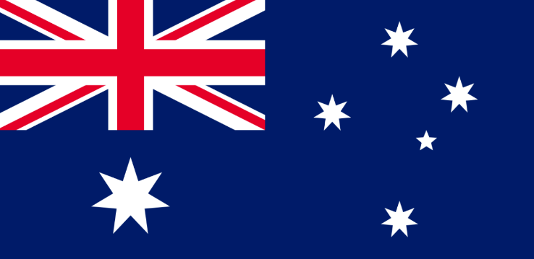

Activity 5: I am not a bear!

Kevin spends a lot of time sitting in eucalyptus trees. His favourite food is eucalyptus leaves.

Activity 6: Make your own Kevin

Choose one of the Koala’s below to make:
You will need:

Paper plates or 2 paper circles
Paper or card for 2 ears, 2 eyes,
nose and 4 paws
Paint or crayons
Glue or tape

Method:

1. Paint or crayon your body parts
2. Use your glue to stick the body
parts together to make your
own Kevin

You will need:
Newspaper, magazines or
junk mail
Plain paper for eyes and
a nose
Black felt tip
Glue

Method:

1. Cut out your shapes
2. Glue your shapes to together to make your own Kevin
3. Colour your eyes and nose and stick them on to Kevin’s
face.
Activity 7: Ready for a snack?

Ingredients:

Banana (2 slices)
Bread or toast
Butter / margarine
Chocolate spread or
Peanut butter
2 Raisins or cherries
1 Grape or strawberry

Or, use any fruit of your choice cut to shape

Method:

- Make your toast
- Butter your bread or toast
- Use a knife to spread chocolate spread / peanut butter over your bread
- Cut 2 slices of banana and place these at the top in the corners for ears
- Place 2 raisins or cherries on the face for eyes
- Cut a grape or strawberry in half and put this in the middle
for Kevin’s nose
When you have cleared up sit down and enjoy your snack.

Activity 8: Washing up

- Put all your dirty things in the sink
- Put any rubbish in the bin, remember to recycle
- Wash up all your equipment
- Use a cloth to wipe the table
- Check the floor and clear up any mess
- Wash your hands and put everything away

Activity 9: Me time

After all your hard work take five minutes ME time. If the rain has stopped or the sun is shining and you have a garden, go outside for some fresh air.

- Find a quiet place,
- Sit down and make yourself really still
- Close your eyes and count to 5
- Open your eyes and stand up slowly
- Give yourself a little shake
- Now: Stop, look, listen…
- Look around you, really look…
- Identify and Name:

5 things you can see
4 things you can feel
3 things you can hear
2 things you can smell
1 thing you can taste

Well done everyone. This is the end of our school Silly Squad reading challenge.

Give yourself a squeeze hug:

Remember to keep reading and sharing your stories.
Have a wonderful summer.
See you all in September.

HAPPY HOLIDAYS EVERYONE

