Here is a selection of apps for the iPad that I have used in music therapy settings - they are particularly useful for clients with more complex or sensory needs and the iPad can be very helpful in developing motor skills, encourage vocalisations and interactive skills.
Having said that some of the apps can be used to create wonderful & sophisticated multi-track recordings.

App | Icon | What is it? | Therapeutic use
Magic Piano | 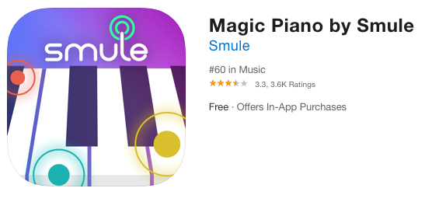 | Can be used to learn to play tunes but also has a very fluid keyboard and black screen - very useful for people with minimal movement. | In the menu set to ‘solo play’ to use the black screen which would pick up even tiny finger movements. Or play on a circular, wavy or spiral piano.
Bloom HD  (£3.99) | 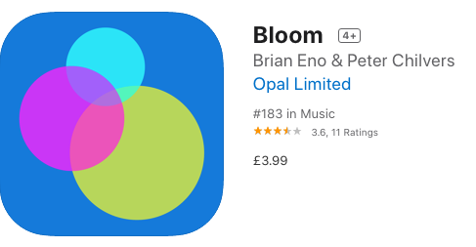 | A simple looper which slowly repeats patterns of sound and visual patterns in response to touch. | Good for relaxation or clients who need time to process what they have done. Good for those with minimal movement as sounds appear instantly and deliberate fine motor control is not required.
Echo strings (lite) | 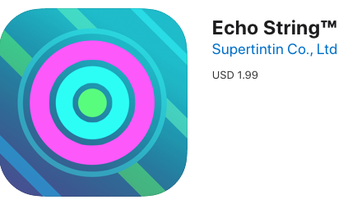 | Relaxing string sounds | Either use it to play harp sounds or play using bass middle and top strings.  You can set it to play in different keys.  There is a record function to listen back.
Drum kit | 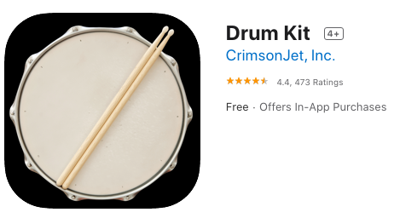 | Whole screen becomes a drum kit. You can record and play along to music. Some versions provide a choice of kits. | Good for fine motor skills and rhythm practice.  Possible to produce real kit sounds to play along to favourite music.
Fingertip maestro | 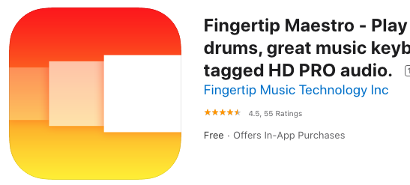 | Colourful bands of sounds. Piano sound with ability to record. | Very easy to produce and change notes for those with minimal movement. Ability to help learn colours or assess understanding if used as a musical colours game.
Sound prism | 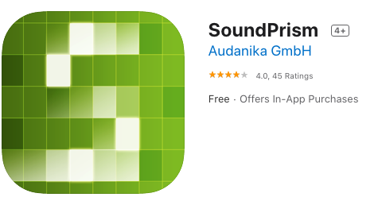 | Plays chords using sound blocks of squares. | You can change key & colour, change the amount of notes that play & record your piece. Good for creating harmonic sounds which always harmonize together.
Airharp | 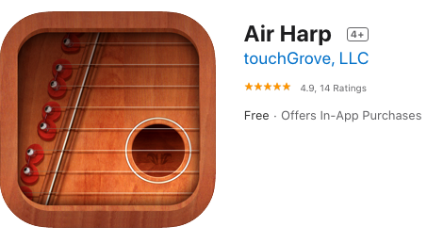 | Zither like harp with authentic sound. | This can be used to learn to play songs but you can also remove the note guides (tap the treble clef) to play freely.
Bebot (£1.99) | 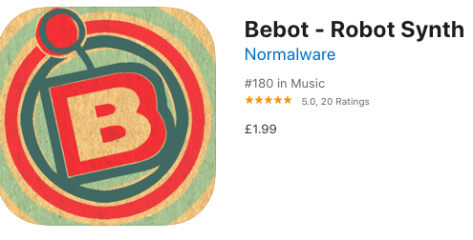 | Cartoon singing robot which moves his mouth as he sings. | Try to copy his mouth shapes and interact by having a conversation. Good to encourage vocalization.
Draw stars | 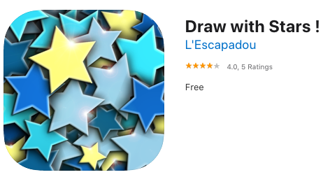 | Draws stars as you touch the screen and they fly away as you touch them again. | There is some quiet backing music as you play this app but it is good for developing motor skis, it is relaxing and cold be used as a visual cue while singing about the stars or singing twinkle together.
Mika | 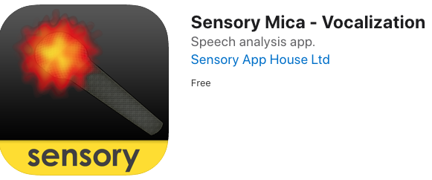 | The screen responds to sounds. You can control the response using sliders to make it more sensitive and change the shape. | Great app for encouraging vocal sounds. It can even respond to breathing sounds if close up. Could also have uses for hearing impaired clients.
- Sansula | 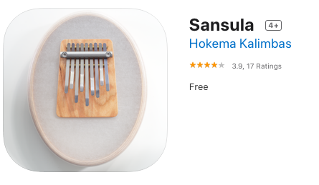 | Lovely sounding thumb piano.  Touch the end of each tine to create the sound. Works well on a phone size device playing with your thumbs | Invent a pattern to repeat over and over.  Great for fine motor skills or play as relaxation for others.
Interactive nursery rhymes | 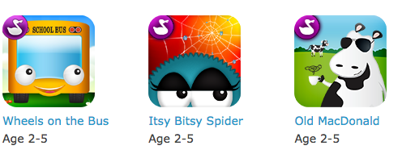 | Itsy Bitsy Spider, Whells on the Bus & Old MacDonald are all designed by Duck duck Moose | Each page has things to find, touch or slide. Making it interactive rather than just watching a screen. Familiar songs and settings enable you to record in you own voice or delay the page turn.
Garageband | 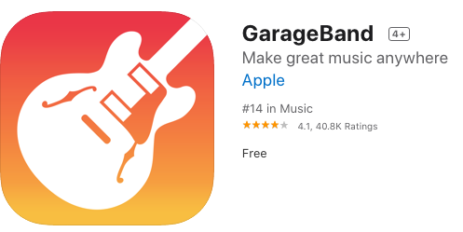 | Garageband is a large collection of touch controlled instruments, samples, loops, beats and a recording studio. | Fantastic app for more able clients to access a variety of instruments, to record their playing and to multi track music.  It can also record from the room and recordings can be a combination of samples, sounds from the app and also sounds recorded into the app using the mic on the iPad. Finished recordings can be mixed & exported by email or other platforms.
Karen Morrison April 2020

