Activities for Wren pupils – ‘Transport – Planes, trains and automobiles’

Monday 22nd June 2020
Wake and Shake – PE with Joe Wicks https://www.youtube.com/watch?v=OBdmt0IEFl4
Mindfulness colouring – Vehicle colouring
History –.Transport old and new powerpoint . Activities - History of transport timeline & past & present transport sort
Maths - Sorting exercise of vehicles – 1) Wheels and no wheels 2) Air, land, sea
Recovery Curriculum Activity – A bucket full of kindness & Be kind to yourself
Science – To be sent by Helen N – Electricity circuits (from last week)

Tuesday 16th June 2020
Wake and Shake – Go Noodle https://family.gonoodle.com/
Reading –spellings Group 1 - FP, BB, Complete * - Phase 3 booklet & Picture captions
‘ph’ wordsearch, or crossword
English – Transport Wordsearch & sentence writing activity using transport stimulus
Maths - Transport Tally Sheet
Food Technology – Grating and slicing – Making a mini Pizza (See instruction sheet)
Science – To be sent by Helen N- Electricity circuits

Wednesday 17th June 2020
Wake and Shake – PE with Joe Wicks https://www.youtube.com/watch?v=OBdmt0IEFl4
Reading – Spellings – Group 1 - FP, BB, Complete * - Phase 3 booklet & Picture captions
Group 2 – CO, RM, JM, JD complete **; HFW words from the Yr ¾ previously sent Group 3 – PB, KP, JW complete ***; Yr 5/6 previously list sent via email previously
Maths – Transport block & bar charts block diagram
English – Reading Comprehension – The Titanic
Group 1 - FP, BB, Complete *; Group 2 – CO, RM, JM, JD complete **; Group 3 – PB, KP, JW complete ***
Art – Design & paint a rock – A community garden in Linton would like to us decorate stones/ rocks to cheer up people sitting and passing by the garden – the garden is mostly used by vulnerable and elderly residence in the near by bungalows. Our theme this week is transport – it would be nice if you would decorate your rock with this in mind.
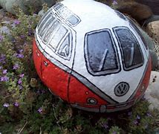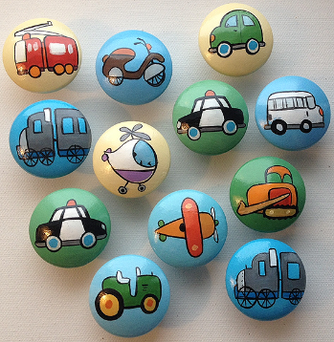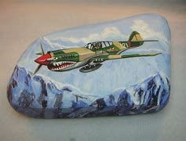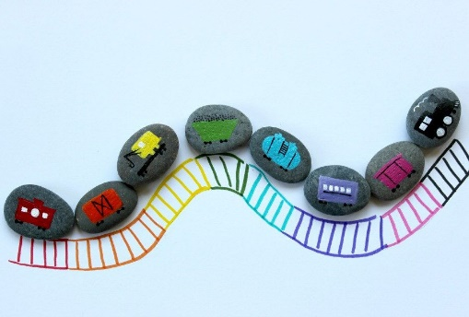
PE – See school website

Thursday 18th June 2020
Wake and Shake –Go noodle https://family.gonoodle.com/
Fine Motor skills – Transport pattern activities
Maths- Train timetable – Questions based on the train time table Group 1 - BB, JD, CO, KP Complete *; Group 2 –, RM, JM, PB, JW complete **; Extension –complete ***
ICT- Photograph 10 different Vehicles that pass by your window/you can see from your garden (or research some images using the internet)
English – Play the transport guessing game – Can you make some of your own cards using the images you took earlier, and creating your own ‘Guess who’ questions.
DT – Make a model of mode of transport (plane, submarine, bike, car, etc) – use junk modelling, play doh etc to make a model of a type of transport

Friday 12th June 2020
Wake and Shake – Yoga - https://www.cosmickids.com/
Reading – Spellings – Group 1 - FP, BB, Complete * - Phase 3 booklet & Picture captions
‘Ear’ spelling sentences Group 2 – CO, RM, JM, JD PB, KP, JW
English – Listening activity =- Airport Scene – & Questions
Maths –White Rose Friday Maths Challenge –Complete the activity and you will receive a certificate!
Manga High activities – ½ hr on set activities on fractions; ½ hr on choosing games on Manga High.
PSD – Looking after your self – Worksheet & discussion
Creativity Afternoon Challenge – Balloon Rocket – See PDF attached
Please photograph/video your making and end result and send to me please

Faith and Assembly –
Please have a look at the Oak National academy Faith & Assemblies – some lovely presentations this week to support Resilience
https://classroom.thenational.academy/

Also Newsround & Blue Peter
There have been some great responses on Newsround & Blue Peter that approaches the subject of Racism.
https://www.bbc.co.uk/newsround/52917648
https://www.bbc.co.uk/cbbc/watch/bp-advice-for-helping-to-stop-racisim

